Chapter 7, Solution 21.

In the circuit in Fig. 7.101, find the value of R for which the steady-state energy stored in the inductor will be 1 J.

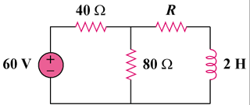

Figure 7.101
For Prob. 7.21.

Solution

The circuit can be replaced by its Thevenin equivalent shown below.

2 H

R_{th}

V_{th}

+

13.333 Ω

